Biobank and Biospecimen Management System

Student Information

Student Name: Tahia Eslam

Student ID: 241001660

Project Name: Biobank and Biospecimen Management System

Database Management System: MySQL

1. Problem Statement :

Biobanks need to manage information about donors, biological samples, storage locations, researchers, laboratory test requests, instruments, and test results.
Managing this information manually can make it difficult to keep records organized and maintain relationships between different types of data.
The aim of this project is to develop a relational database for a Biobank and Biospecimen Management System. The database stores the main information related to donors and biospecimens and connects the related records using primary keys and foreign keys.
The system also includes views and a trigger to support common database operations and enforce an important business rule related to donor consent.

2. Project Scope:

The database manages the following main areas:
. Donor information.
. Sample types and descriptions.
. Sample storage locations.
. Researchers and their departments.
. Biospecimen samples collected from donors.
. Laboratory test requests.
. Laboratory instruments.
. Test results.
The database also provides SQL queries for retrieving and analyzing information, two database views, and a trigger that prevents samples from being added when the donor has not given consent

3. Main Business Rules:

The main business rules implemented in the database are:
1. Every donor has a unique Donor ID.
2. Every sample has a unique Sample ID.
3. A sample can be associated with a donor, sample type, and storage location.
4. A test request is associated with a sample and a researcher.
5. A test result is associated with a test request and an instrument.
6. Researcher email addresses must be unique.
7. A sample should not be inserted when the related donor has not given consent.
8. Test request status has a default value of Pending.
In addition, primary keys are used to uniquely identify records in each table, while foreign keys maintain the required relationships between related entities. Unique constraints are used for attributes that must not contain duplicate values, such as researcher email addresses.

4. Entities and Attributes
1- Donors
Primary Key:
Donor ID
Attributes:
. Donor ID
. Full Name
. Gender
. Birth Date
. Consent Given
The Donors table stores information about people who provide biological samples.
2- Sample Types
Primary Key: Type ID
Attributes:
. Type ID
. TypeName
. Description
This table stores the different types of biological samples, such as blood, plasma, serum, saliva, and tissue.
3- Storage Locations
Primary Key:
Location ID
Attributes:
. Location ID
. Freezer Name
. Shelf Number
. Box Number
This table stores the physical storage location of samples.
4- Researchers
Primary Key: Researcher ID
Attributes:
. Researcher ID
. Researcher Name
. Email
. Department
The Researchers table stores information about researchers who request laboratory tests.
5- Samples
Primary Key: Sample ID
Foreign Keys:
Donor ID
. Type ID
. Location ID
Attributes:
. Sample ID
. Donor ID
. Type ID
. Location ID
. Collection Date
. Volume ML
This table stores the actual biospecimen records.
6- Test Requests
Primary Key: Request ID
Foreign Keys:
. Sample ID
. Researcher ID
Attributes:
. Request ID
. Sample ID
. Researcher ID
. Test Name
. Request Date
. Status
This table stores laboratory test requests for samples.
7- Instruments
Primary Key: Instrument ID
Attributes:
. Instrument ID
. Instrument Name
. Model Number
. Calibration Date
This table stores information about laboratory instruments used for testing.

8- Test Results
Primary Key: Result ID
Foreign Keys:
. Request ID
. Instrument ID
Attributes:
. Result ID
. Request ID
. Instrument ID
. Result Data
. Completion Date
This table stores the results produced for test requests.

5. ER Diagram

The ER diagram represents the entities, attributes, primary keys, foreign keys, and relationships in the database.
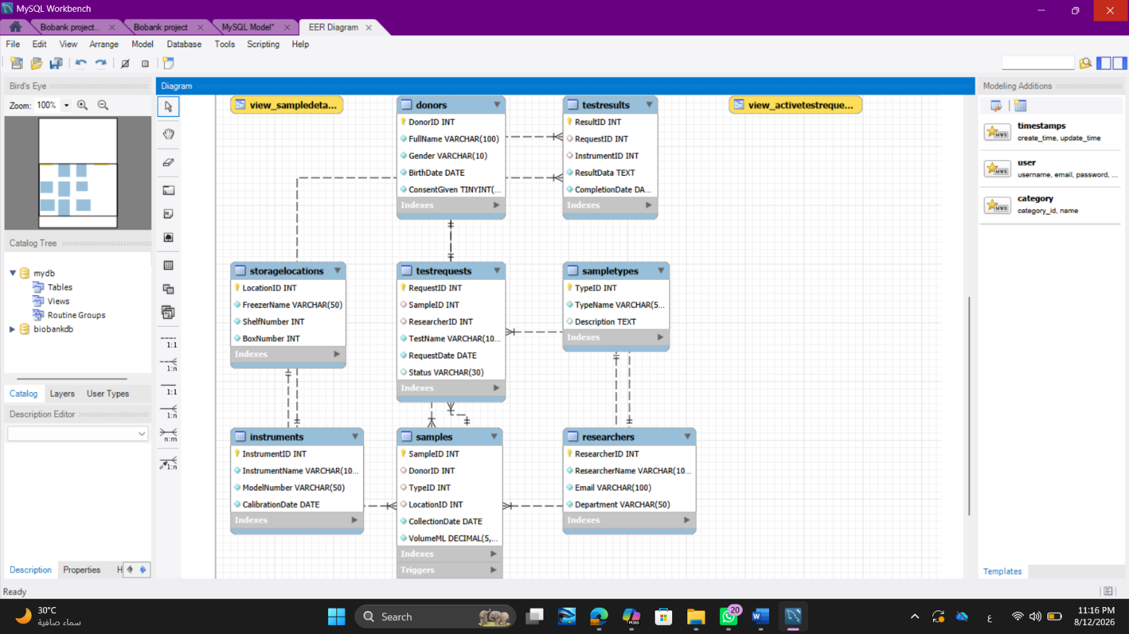
Figure 1. Entity-Relationship Diagram of the Biobank and Biospecimen Management System

The main relationships represented in the database are:
. A donor can have multiple samples.
. A sample type can be associated with multiple samples.
. A storage location can contain multiple samples.
. A researcher can make multiple test requests.
. A sample can have multiple test requests.
. A test request can have a test result.
. An instrument can be used for multiple test results.

The ER diagram is included separately in the diagrams folder as ERD.png.

6. Relational Schema
The relational schema is implemented using the following tables:
Each table has a primary key that uniquely identifies its records. The foreign keys establish relationships between related tables and maintain referential integrity. Candidate keys were considered during the design, and the selected primary key represents the main unique identifier for each entity. In the Researchers table, Email is also a candidate key because it is required to be unique and is enforced using a UNIQUE constraint.
Donors
For example, donor information is stored in the Donors table rather than being repeated for every sample. Sample type information is stored separately in SampleTypes, and researcher information is stored separately in Researchers.
The relational schema of the Biobank and Biospecimen Management System consists of eight main relations. Primary keys uniquely identify records, while foreign keys establish relationships between related tables.
The relational schema is implemented using the following tables:

Each table has a primary key that uniquely identifies its records. Foreign keys establish relationships between related tables and maintain referential integrity. Candidate keys were considered during the design, and the selected primary key represents the main unique identifier for each entity. In the Researchers table, Email is also a candidate key because it is required to be unique and is enforced using a UNIQUE constraint.
Donors
Donor ID (PK), Full Name, Gender, Birth Date, Consent Given
Sample Types
Type ID (PK), TypeName, Description
Storage Locations
Location ID (PK), Freezer Name, Shelf Number, Box Number
Researchers
Researcher ID (PK), Researcher Name, Email (UNIQUE), Department
Samples
Sample ID (PK), Donor ID (FK), Type ID (FK), Location ID (FK), Collection Date, Volume ML
Test Requests
Request ID (PK), Sample ID (FK), Researcher ID (FK), Test Name, Request Date, Status
Instruments

Instrument ID (PK), Instrument Name, Model Number, Calibration Date

Test Results

Result ID (PK), Request ID (FK), Instrument ID (FK), Result Data, Completion Date
The main foreign key relationships are as follows:
Samples Donor ID references donor ID.
samples Type ID references Sample Types Type ID.
Samples Location ID references Storage Locations Location ID.
Test Requests Sample ID references Samples Sample ID.
Test Requests Researcher ID references Researchers Researcher ID.
Test Results Request ID references Test Requests. Request ID.
Test Results Instrument ID references Instruments Instrument ID.

The Researchers Email attribute is defined as UNIQUE to prevent duplicate researcher email addresses. This relational schema represents the database structure after mapping the entities and relationships from the conceptual ER model into relational tables.

7. Normalization:

The database separates different types of information into different tables to reduce unnecessary duplication.

Primary keys uniquely identify records, while foreign keys connect related tables.
The database is designed to satisfy the requirements of Third Normal Form (3NF).

First Normal Form (1NF): Each table contains atomic values, meaning that each attribute contains a single value and there are no repeating groups. For example, each donor has one DonorID, one name, one gender, and one birth date.

Second Normal Form (2NF): The database tables use primary keys to uniquely identify records, and non-key attributes depend on the complete primary key of their respective table. Since the tables mainly use single-attribute primary keys, partial dependencies are avoided.

Third Normal Form (3NF): Non-key attributes depend only on the primary key and not on other non-key attributes. For example, donor information is stored only in the Donors table, while sample information is stored in Samples. Similarly, researcher information is stored in Researchers and sample type information is stored in Sample Types. This reduces redundancy and avoids transitive dependencies.

Therefore, separating the entities into individual tables and connecting them using foreign keys results in a relational design that satisfies 3NF.

8. Database Implementation
The Biobank and Biospecimen Management System was implemented using MySQL as the relational database management system. The database was designed to store and manage information about donors, biological samples, sample types, storage locations, researchers, laboratory test requests, laboratory instruments, and test results.

The database consists of eight main tables. Each table has a primary key to uniquely identify its records, while foreign keys are used to establish relationships between related tables and maintain referential integrity.

8.1 Database Creation

The database was created using the following SQL statement:
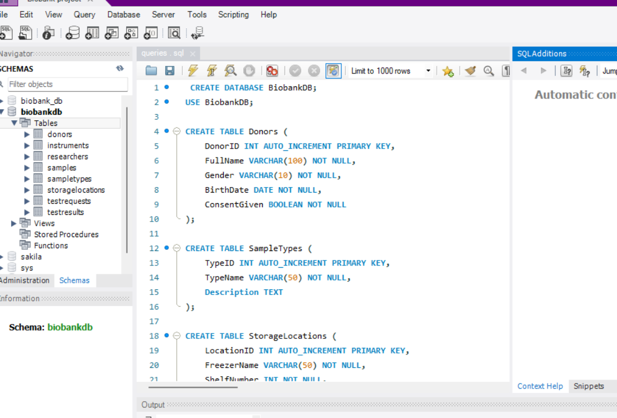CREATE DATABASE Biobank DB;
The project contains eight tables:”
The database contains the following main tables:

1. Donors
2. Sample Types
3. Storage Locations
4. Researchers
5. Samples
6. Test Requests
7. Instruments
8. Test Results

8.2 Table Implementation

The Donors table stores information about individuals who provide biological samples. It contains Donor ID as the primary key, along with Full Name, Gender, Birth Date, and Consent Given.

The Sample Types table stores the different types of biological specimens used in the system. It contains Type ID as the primary key, together with TypeName and Description.

The Storage Locations table stores information about where samples are physically stored. It contains Location ID as the primary key, along with Freezer Name, Shelf Number, and Box Number.

The Researchers table stores information about researchers who request laboratory tests. Researcher ID is the primary key, while Email has a UNIQUE constraint to prevent duplicate researcher email addresses.

The Samples table stores the actual biospecimen records. Sample ID is the primary key, while Donor ID, Type ID, and Location ID are foreign keys that connect each sample to its donor, sample type, and storage location. The table also stores Collection Date and Volume ML.

The Test Requests table stores laboratory test requests associated with biological samples. Request ID is the primary key, while Sampl ID and Researcher ID are foreign keys. The table also stores Test Name, Request Date, and Status. The Status attribute has a default value of Pending.
The Instruments table stores information about laboratory instruments used to perform tests. Instrument ID is the primary key, while Instrument Name, Model Number, and Calibration Date provide information about each instrument.
The Test Results table stores the results produced for laboratory test requests. Result ID is the primary key, while Request ID and Instrument ID are foreign keys. The table also stores Result Data and Completion Date.

8.3 Integrity Constraints
Several integrity constraints were implemented to maintain the consistency and reliability of the database.
Primary key constraints ensure that every record has a unique identifier.
Foreign key constraints maintain valid relationships between related tables and prevent invalid references.
The UNIQUE constraint on Researchers Email prevents duplicate email addresses from being stored for different researchers.

The default value of Pending for Test Requests Status ensures that new test requests have an initial status when no status is specified.

The donor-consent trigger provides an additional business rule by preventing the insertion of a new sample when the related donor has not given consent.

8.4 SQL Implementation Files

The SQL implementation was organized into separate files to make the project easier to execute and maintain.
The create tables sql file contains the database tables and their constraints.
The load_ data. Sql file contains the test data inserted into the database.
The queries. sql file contains SQL queries for data retrieval, joins, aggregation, subqueries, and data modification operations.
The views. sql file contains the two database views used by the system.
The trigger _procedures. Sql file contains the donor-consent trigger used to enforce the sample consent business rule.

8.5 Database Execution

After executing the SQL scripts in MySQL, the database and its tables were successfully created and populated with test data. The relationships between the tables were verified using SQL queries and joins.

The database was also tested to ensure that the implemented constraints, views, and trigger work correctly and support the required business rules.

9. Sample Data:

The database includes sample data for donors, sample types, storage locations, researchers, samples, test requests, instruments, and test results.
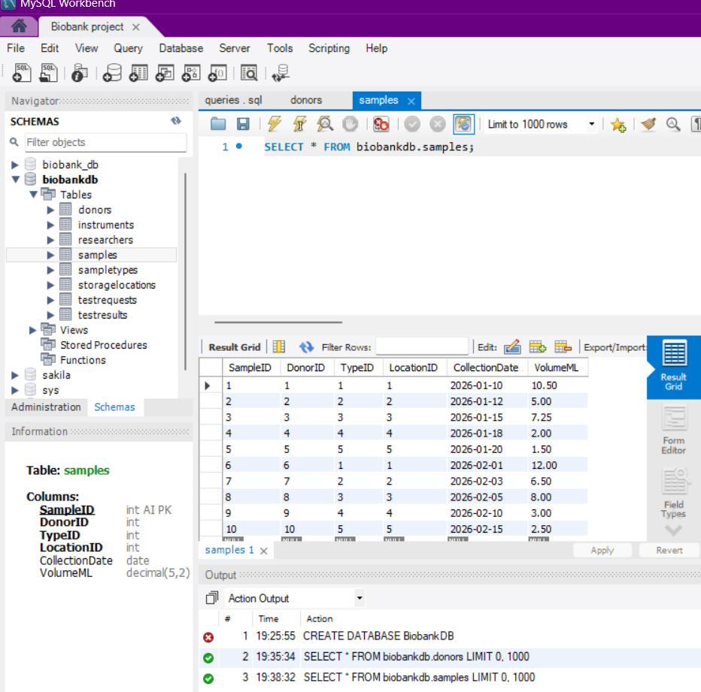
The Donors table contains 10 donor records, and the Samples table contains 10 sample records.

The smaller reference tables contain fewer records because they represent categories, locations, researchers, and instruments used by the main records.

10. SQL Queries and Database Operations

The project includes SQL operations for retrieving and analyzing database information.

Examples include:
Sample and Storage Information
A query joins Samples, Donors, and Storage Locations to display sample IDs, donor names, freezer names, and box numbers.
Average Sample Volume
An aggregation query calculates the average sample volume using AVG(VolumeML).
Subquery
A nested query retrieves samples whose volume is greater than the average sample volume.

The complete queries are included in queries.sql.
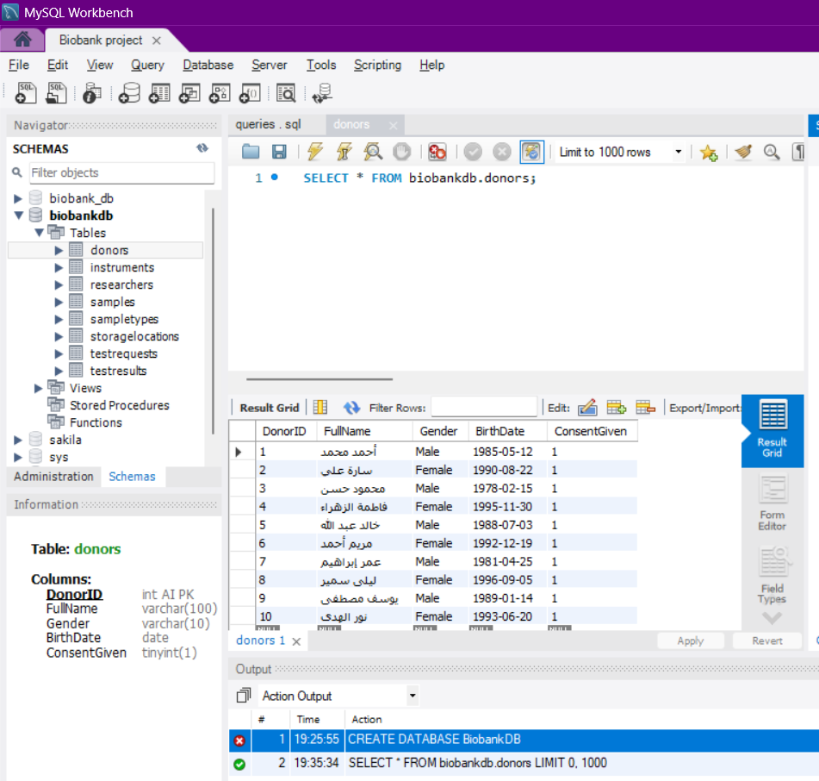

In addition to data retrieval and analysis, the project includes data modification operations. INSERT statements are used to add new records, UPDATE statements are used to modify existing information, and DELETE statements are used to remove records when required. These operations are tested while maintaining the primary key, foreign key, unique, and other integrity constraints.

11. Database Views
The project contains two views.

11.1 View _ Sample Details
This view combines information from:
. Samples
. Donors
. Sample Types
It displays:

. Sample ID
. Donor name
. Sample type
. Collection date
. Sample volume

This view makes it easier to retrieve common sample information without writing the joins repeatedly.
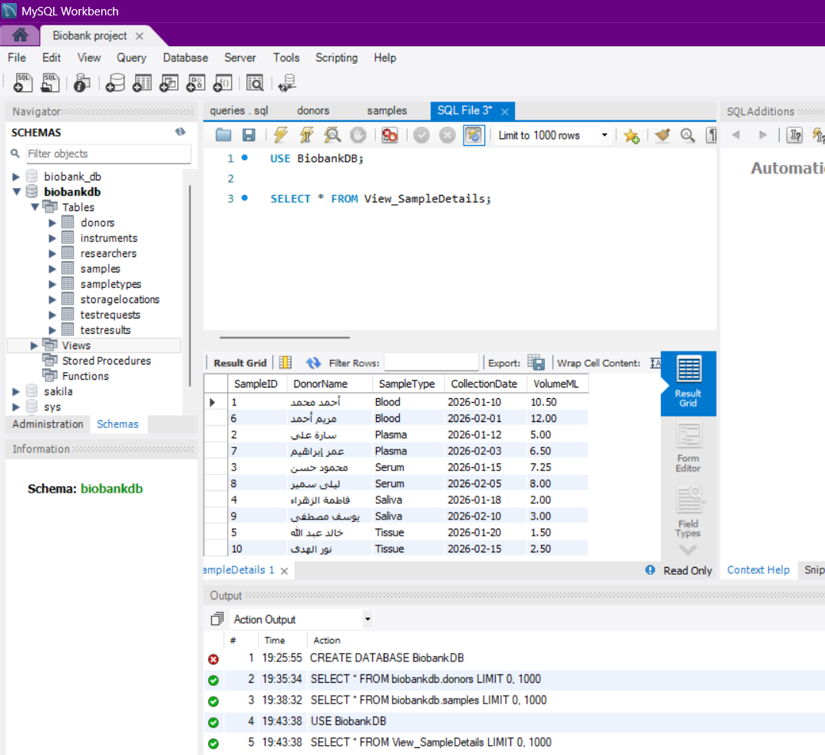
Figure 5. View _ Sample Details output in MySQL Workbench.

11.2 View _ Active Test Requests
This view combines Test Requests with Researchers.
It displays:
. Request ID
. Researcher name
. Test name
. Status
. Request date
The views are implemented in views .Sql .

12. Trigger:

The project includes a trigger named Check Donor Consent.
The trigger runs before a new sample is inserted into the Samples table.
It checks the Consent Given value of the related donor. If the donor has not provided consent, the trigger prevents the sample from being inserted and returns an error message.
This trigger supports an important business rule: biological samples should not be added to the system when donor consent has not been given.
The trigger is included in triggers _ procedures .Sql

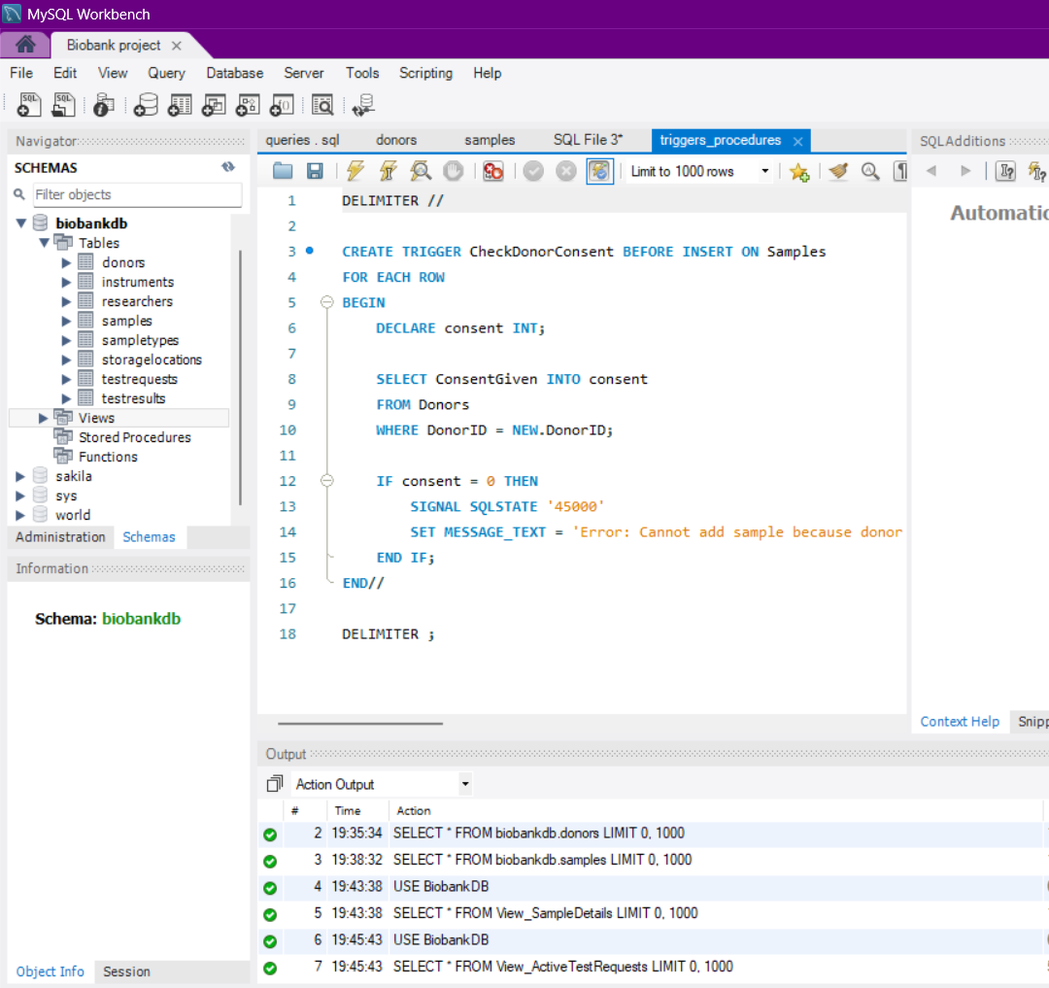

13. Testing:

Testing is performed to verify that the database tables, relationships, queries, views, and trigger work correctly.

Examples of testing include:

. Checking that tables are created successfully.
. Checking that sample records can be inserted.
. Checking relationships using joins.
. Testing the average sample volume query.
. Testing the subquery for samples above the average volume.
. Checking that the two views return the expected information.
. Testing the donor-consent trigger.
The testing process also verifies important integrity constraints and business rules. In particular, the donor-consent trigger was tested by attempting to insert a sample for a donor who had not given consent. The insertion was rejected and an error message was returned. A valid sample insertion was also tested for a donor who had given consent, confirming that valid records can be added successfully.

The UNIQUE constraint on researcher email addresses and the foreign key relationships were also considered during testing to ensure that invalid or inconsistent records are not accepted by the database.

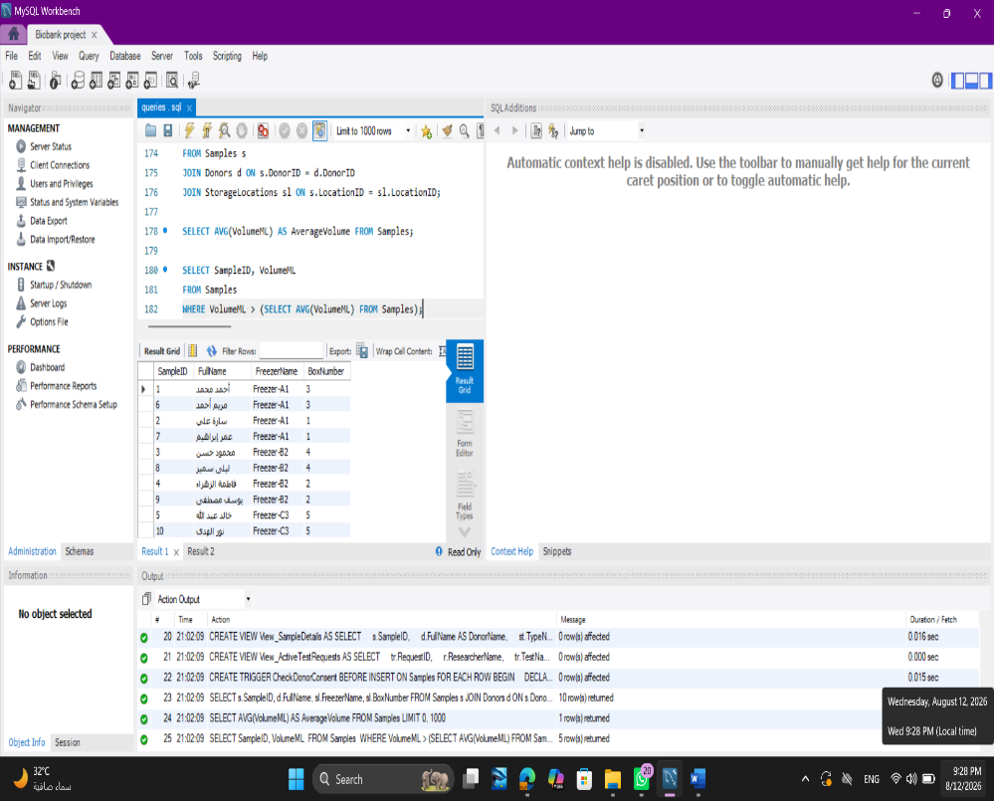

14. Limitations:

The current database focuses on the core management of donors, biospecimens, storage, researchers, test requests, instruments, and test results.
Some advanced features such as a connected user interface are not included in the current implementation.
The project can be extended in the future with additional functionality such as sample usage history, aliquot management, collection events, and a user interface connected directly to the database.

15. Conclusion:

The Biobank and Biospecimen Management System provides a relational database for organizing important biobank information.
The project demonstrates database design and implementation using entities, primary keys, foreign keys, constraints, sample data, SQL queries, views, and a trigger.
The database structure separates related information into appropriate tables and provides relationships between the different parts of the system. The implemented queries, views, and trigger also support data retrieval, analysis, and enforcement of an important business rule.

16. References:
1. Fundamentals of Databases – Biotechnology Database Project Guidelines. Course project guidelines provided by the instructor.
2. Oracle. (2026). MySQL 8.4 Reference Manual. MySQL Documentation.

